Block Diagram Reduction
- Blocks in series | 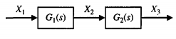  $X_{2}=G_{1}X_{1}$ $≪≫ X_{3}=G_{2}X_{2}$  $$X_{3}={G_{1}G}_{2}X_{1}$$ | 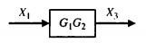
- Parallel blocks | 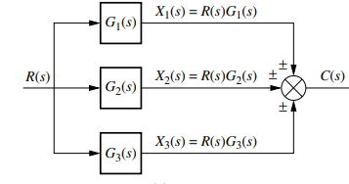 | 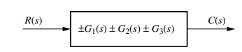
- Moving a summing point ahead of a block | 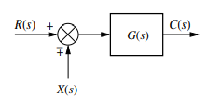  $C\left(s\right)=\left\{R\left(s\right)∓X\left(s\right)\right\}G(s)$ | 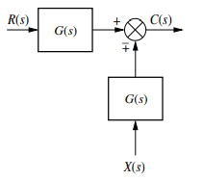  $C\left(s\right)=\left\{R\left(s\right)G(s)∓X\left(s\right)G(s)\right\}$
- Moving a summing point behind of a block | 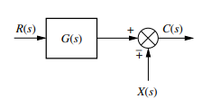  $$C\left(s\right)=R\left(s\right)G(s)∓X\left(s\right)$$ | 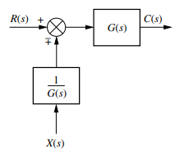  $$C\left(s\right)=\left\{R\left(s\right)∓X\left(s\right)\frac{1}{G\left(s\right)}\right\}G(s)$$
- Moving a pick off point ahead of a block | 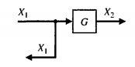 | 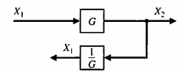  $X_{2}=GX_{1}$ $≪≫ X_{1}=\frac{1}{G}X_{2}$
- Moving a pick off point behind a block | 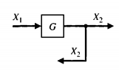  $$Y$$  $$X_{2}=GX_{1}$$ | 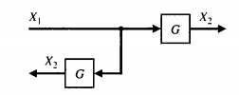
- Reducing a feedback loop | 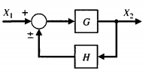  $$Y=X_{1}-Z≫Z=HX_{2}≫$$  $$X_{2}=GY=G\left(X_{1}-Z\right) =G(X_{1}-HX_{2})$$  $$Z$$  $$X_{2}=\left(\frac{G}{1∓GH}\right)X_{2}$$ | 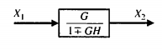

Example 1  Reduce the given block diagram and find the overall transfer function of the system. | 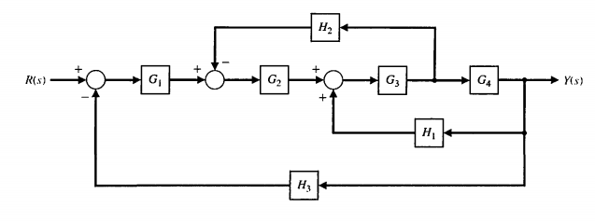
Moving the pickoff point ahead of the block $G_{4}$  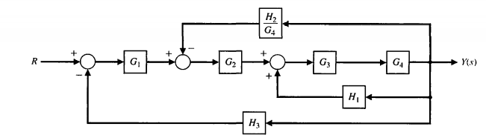 | Combining the series blocks$G_{3}$and $G_{4}$  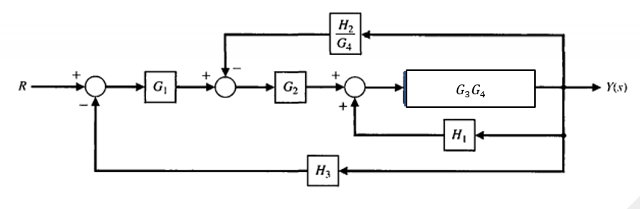
Eliminating the feedback loop  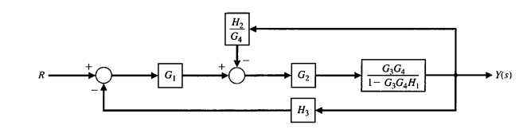 | Combining the series blocks  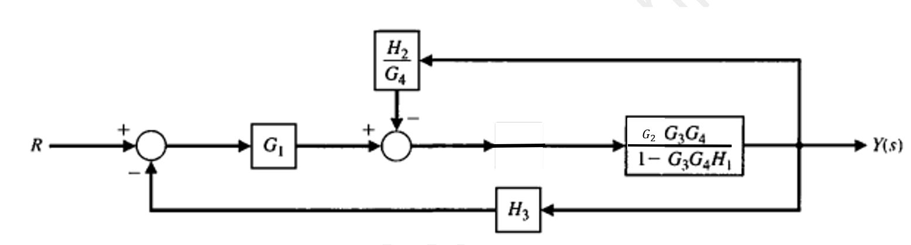
Eliminating the feedback loop  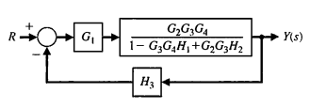 | Combining the series blocks  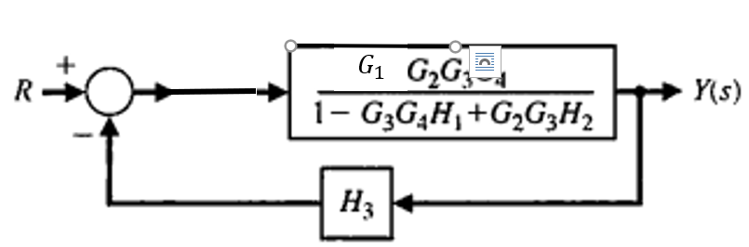
Eliminating the feedback loop
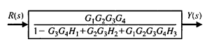

Example 2  Determine the closed loop transfer function $T\left(s\right)=\frac{C(s)}{R(s)}$ | $$H_{3}$$  $$G_{2}$$  $$-$$  $$G_{1}$$  $$H_{1}$$  $$H_{2}$$  $$+$$  $$-$$  $$+$$  $$+$$  $$-$$  $$R(s)$$  $$C(s)$$  $$G_{3}$$
Moving the pickoff point ahead of block $G_{3}$  $$H_{3}/G_{3}$$  $$G_{2}$$  $$-$$  $$G_{1}$$  $$H_{1}$$  $$H_{2}$$  $$+$$  $$-$$  $$+$$  $$+$$  $$-$$  $$R(s)$$  $$C(s)$$  $$G_{3}$$ | Combining the series blocks$G_{2}$and $G_{3}$  $$G_{2}$$  $$-$$  $$G_{1}$$  $$H_{1}$$  $$H_{2}$$  $$+$$  $$-$$  $$+$$  $$+$$  $$-$$  $$R(s)$$  $$C(s)$$  $$G_{3}$$  $$H_{3}/G_{3}$$
Eliminating the feedback loop  $$\frac{G_{2}G_{3}}{1+G_{2}G_{3}H_{2}}$$  /1+  $$G_{1}$$  $$H_{1}$$  $$+$$  $$-$$  $$+$$  $$-$$  $$R(s)$$  $$C(s)$$  $$H_{3}/G_{3}$$ | Moving athe pickoff point ahead of the block  $$\frac{G_{2}G_{3}}{1+G_{2}G_{3}H_{2}}$$  /1+  $$G_{1}$$  $$\frac{H_{1}}{\frac{G_{2}G_{3}}{1+G_{2}G_{3}H_{2}}}$$  $$+$$  $$-$$  $$+$$  $$-$$  $$R(s)$$  $$C(s)$$  $$H_{3}/G_{3}$$
Combining the series block  $$\frac{G_{1}G_{2}G_{3}}{1+G_{2}G_{3}H_{2}}$$  /1+  $$\frac{H_{1}}{\frac{G_{2}G_{3}}{1+G_{2}G_{3}H_{2}}}$$  $$+$$  $$-$$  $$+$$  $$-$$  $$R(s)$$  $$C(s)$$  $$H_{3}/G_{3}$$ | Eliminating the feedback loop  $$\frac{G_{1}G_{2}G_{3}}{1+G_{1}G_{2}H_{3}+G_{2}G_{3}H_{2}}$$  /1+  $$\frac{H_{1}}{\frac{G_{2}G_{3}}{1+G_{2}G_{3}H_{2}}}$$  $$+$$  $$-$$  $$R(s)$$  $$C(s)$$
Eliminating the feed-back loop
$$\frac{G_{1}G_{2}G_{3}}{1+G_{1}G_{2}H_{3}+G_{2}G_{3}H_{2}+G_{1}H_{1}+G_{1}G_{2}G_{3}H_{1}H_{2}}$$
$$R(s)$$
$$C(s)$$

Exercise 1  Determie the closed loop transfer function $T\left(s\right)=\frac{Y(s)}{R(s)}$ | 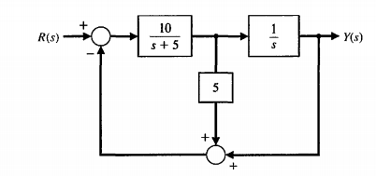
Exercise 2  Determie the closed loop transfer function $T\left(s\right)=\frac{C(s)}{R(s)}$ | 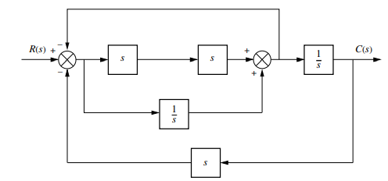
Exercise 3  Determie the closed loop transfer function $T\left(s\right)=\frac{C(s)}{R(s)}$ | 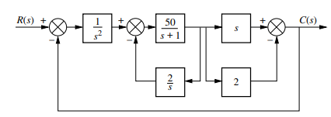
Exercise 4  Determie the closed loop transfer function $T\left(s\right)=\frac{C(s)}{R(s)}$ | 